Experiment 6: Transient Response of a 1st Order RC Circuit

By:

Shawn Keene, Jason Gilman

Supervisor: Saad Muaddi

Data collected on: 10/30/2019

Due: 11/06/2019

ECEN 214-508, Electrical Circuit Theory

Fall 2019

Prof. Scott Miller

**Introduction:**

In this lab students set up a first order equation to demonstrate the uses of inductors and capacitors. The lab also involved introducing students to potentiometers. Capacitors are units that store energy in an electric field. As time goes on without the capacitor being charged it releases voltage at a much quicker rate than a battery. Inductors are units that store energy in a magnetic field, and as they are being charged they release current at a quick rate. For this lab capacitors will be used instead of inductors. Potentiometers are devices that use two resistors with a varying second resistor in order to change the output current using the voltage divider rule.

**Procedure:**

Task 1 of the experiment involved building the circuit below. First students in their prelab calculated the resistor values for R1, R2, and R. This in turn got the frequency as close to 1 as possible.

Task 2 involved replacing the two resistors below with a potentiometer. Once students had setup the potentiometer, they tried getting the frequency as close to 2 Hz as possible. After this, the resistor value R was halved and again the resistor value R2 in the potentiometer was changed two get the measured value to be 2 Hz.

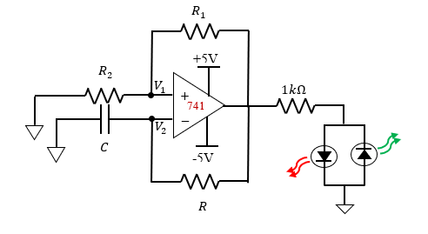

**Data:**

Task 1:

|  |  |  |  |
| --- | --- | --- | --- |
|  | Frequency | P2P | RMS |
| V1 | .9988 Hz | 1.9615 V | .97859 V |
| V2 | .9988 Hz | 1.9567 V | .57455 V |

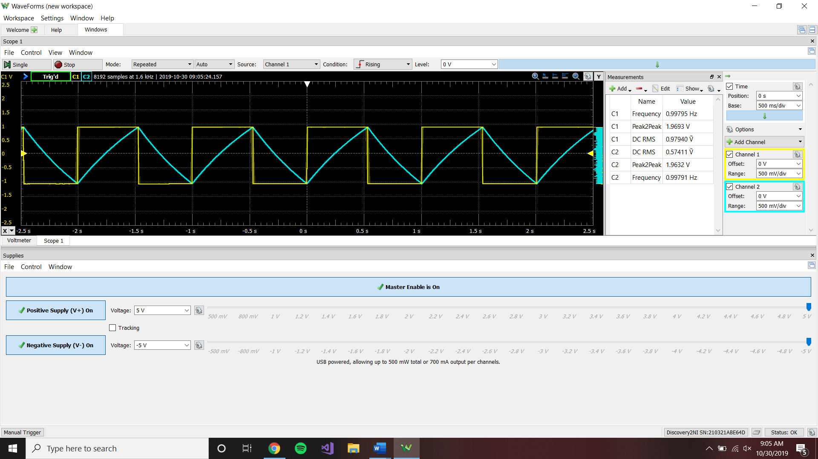

This screen shot shows the waveform for the measurements of the original circuit, set up with the calculated resistor values. The frequency is very close to 1 Hz, so the L.E.D. flashes on/off every 1 second.

Task 2:

|  |  |  |  |  |
| --- | --- | --- | --- | --- |
|  | Frequency | R | R1 | R2 |
| V1 | 1.97 Hz | 100k Ω | 1.3k Ω | 8.7k Ω |
| V2 | 2.072 Hz | 50k Ω | 2.44k Ω | 7.54k Ω |

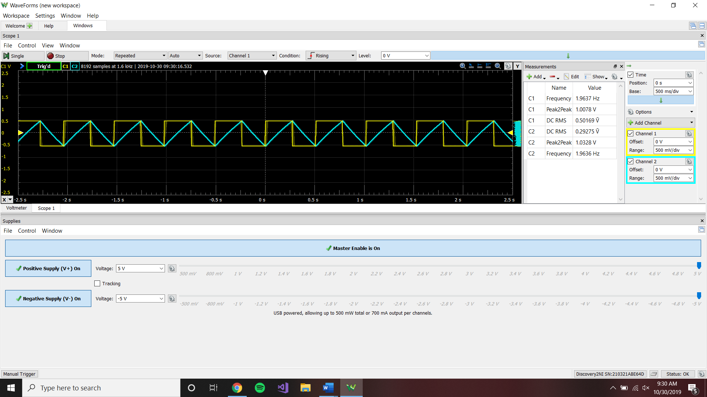

This screenshot shows the circuit being set up with a potentiometer, and oscillating at a frequency of 2 Hz. The L.E.D. blinks faster with this resistor setup as compared to the initial circuit.

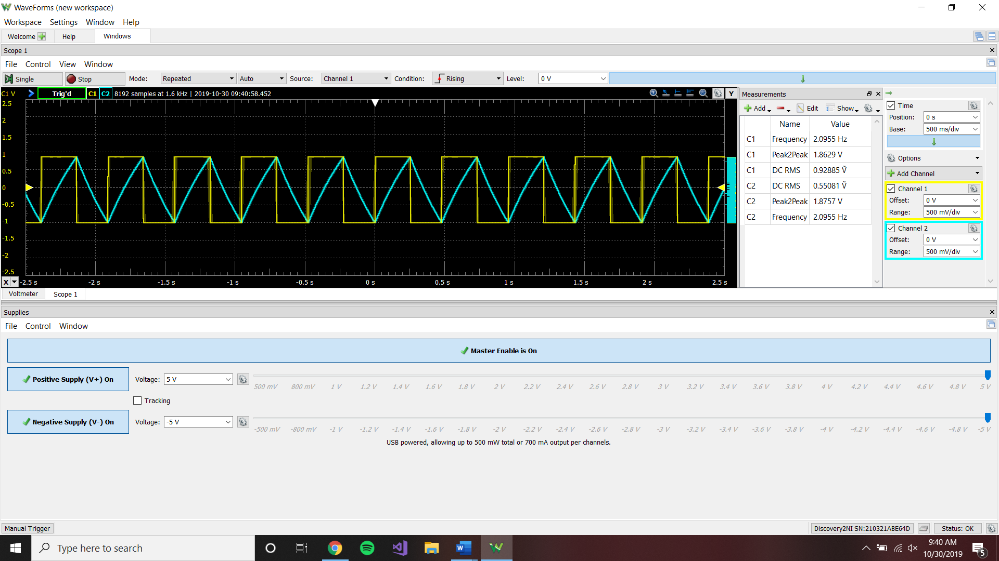

This screenshot shows the circuit being set up with half the value of the initial R, so in this case it was setup with R = 50k Ω. The frequency was brought back up to 2 Hz, by adjusting the potentiometer accordingly.

**Calculations:**

No calculations were made during the lab, the required resistor values were calculated in the prelab.

**Discussion:**

Task one of the experiment went flawlessly. The predicted value for frequency was .979 Hz compared to an actual value of .9988 Hz. The difference in frequency can be attributed to the non perfect ohm value of the resistors. The root mean square and peak to peak voltage are directly related. The predicted values for these two were 1.85V and 1.3V respectively. The measured value again was 1.9615 Vand .97859 V respectively. The error for these two can be attributed to the saturation of the opamp, and again error in the resistor values.

Task two of the experiment also went as expected. The voltage division ratio was found in the potentiometer to be .87 before R was changed and .754..

**Conclusion:**

Overall students used